Part 1

1. Modify the latent space size: Change the noise vector size from 100 to 50 or 200. Observe how this change affects the quality and variety of generated images.

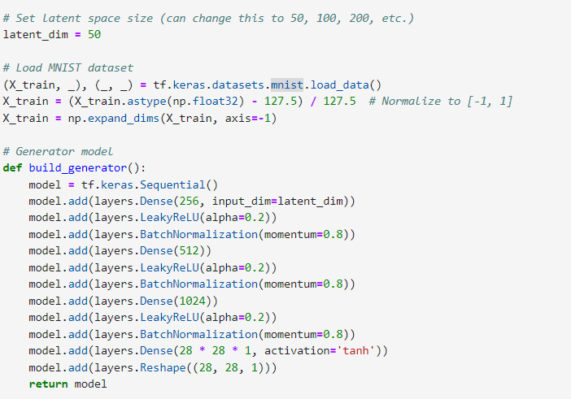

Changing the latent space size from 100 to 50 or 200 can significantly impact the quality and variety of generated images, **with a smaller size (50) potentially leading to less diversity and detail, while a larger size (200) may enhance the model's ability to capture complex patterns,** resulting in more varied and higher-quality outputs

50

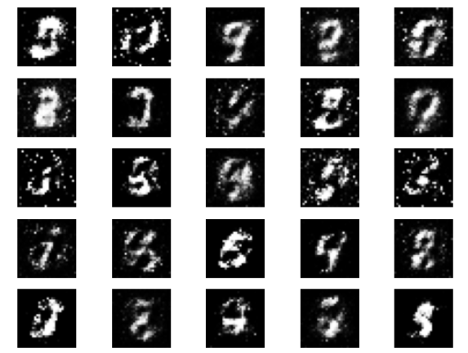

100

200

1. Train the GAN for 10,000 epochs: Save and visualize the generated images at every 1,000 epochs. Create a GIF or a slideshow to show how the quality of the generated images evolves over time.

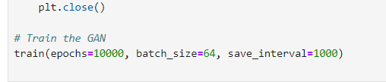

Epoch -0

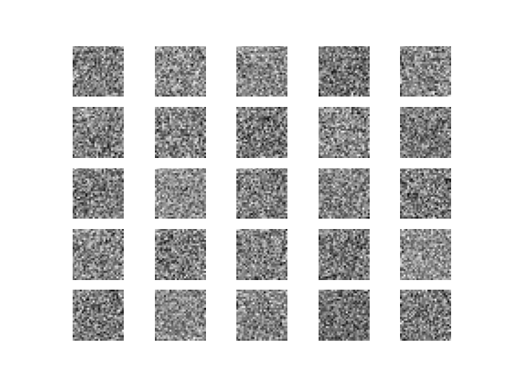

Epoch -1000

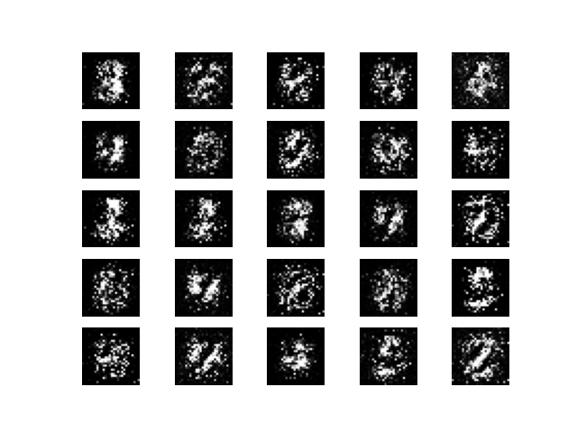

Epoch -2000

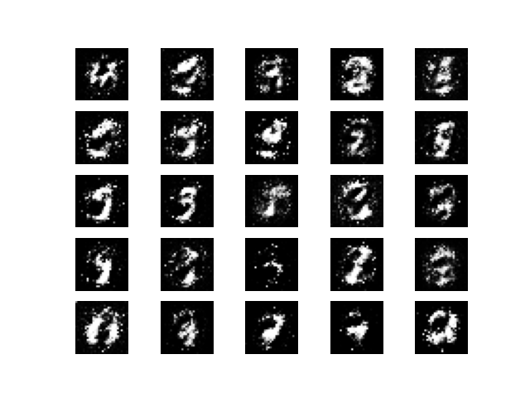

Epoch - 3000

Epoch – 4000

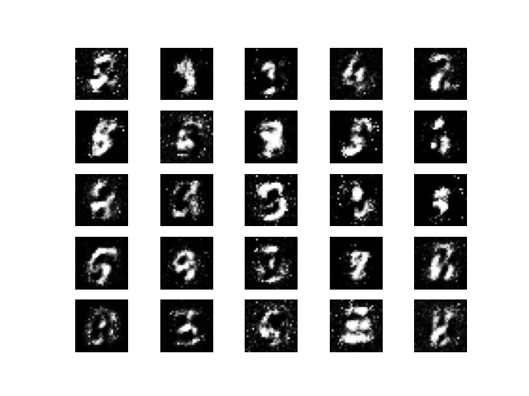

Epoch – 5000

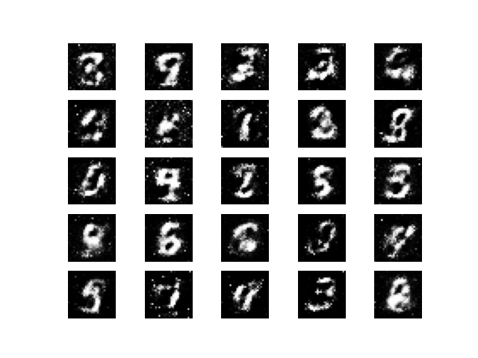

Epoch – 6000

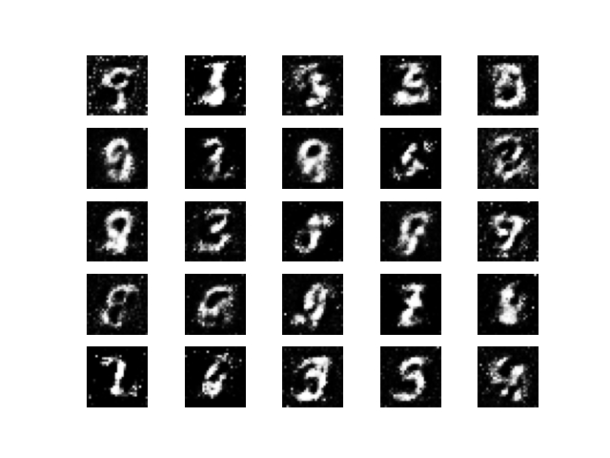

Epoch – 7000

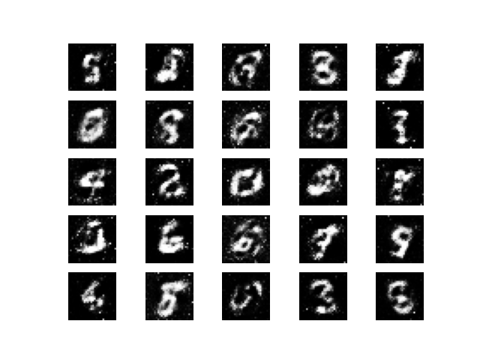

Epoch – 8000

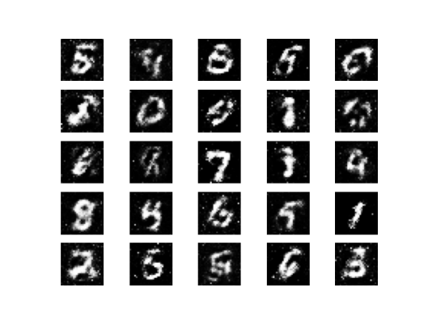

Epoch - 9000

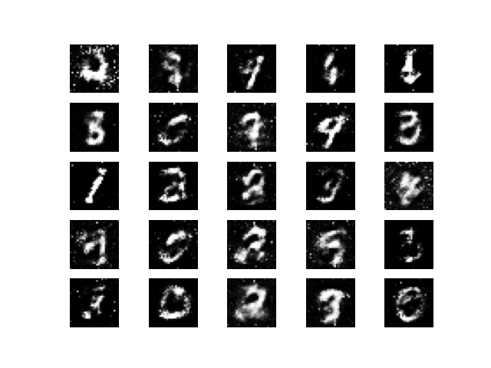

1. Change the optimizer from Adam to RMSprop or SGD for both the generator and discriminator. Observe the impact on training performance and image quality.

**We had the best result From rmsprop**

Adam

Rmsprop

Sgd

1. Experiment with different batch sizes. What impact different batch sizes have on

**For epoch 1000 we had best result for batch size 16,32**

16

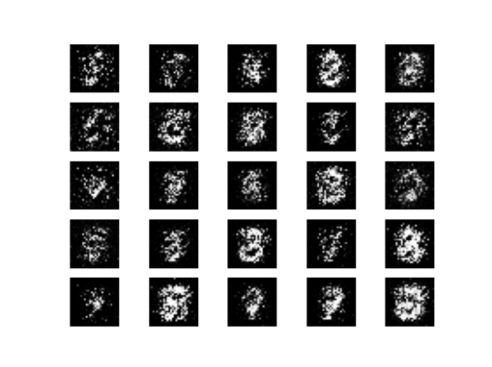

32

64

128

Part 2

1. Modify the CGAN to generate images for specific digits (e.g., generate only '7' or '9').

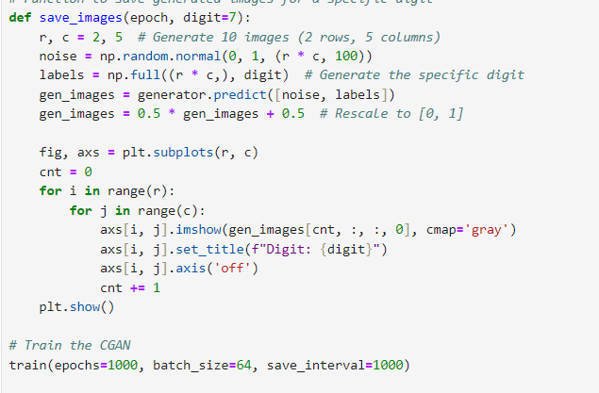

1. Implement label smoothing by replacing real labels of 1 with random values between 0.9 and 1 during training. Analyze how label smoothing affects the training process and the quality of generated images.

**label smoothing helps in creating models that are better generalized by moderating their prediction confidence, which in turn improves the quality and reliability of the generated outputs over the course of training epochs.**

epoch 0

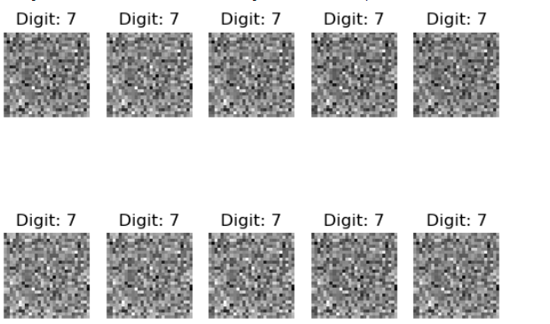

epoch 1000

epoch 2000

epoch 3000

epoch 4000

epoch 5000

epoch 6000

epoch 7000

epoch 8000

epoch 9000

1. Create noise vectors corresponding to two different digits (e.g., '3' and '8'). Perform **interpolation** between the two noise vectors and visualize how the generated images morph from one digit to the other.

**As training progresses, the generated images become clearer and more distinguishable as individual digits.**

**The interpolation shows the capability of the generative model to not only generate realistic digits but also transition smoothly between two different classes.**

**The effectiveness and quality of interpolation depend heavily on the training progress and the learned latent space of the model.**

epoch 0

epoch 2000

epoch 4000

epoch 6000

epoch 8000

